CS 255 System Design Document Template

This template lays out all the different sections that you need to complete for Project Two. Each section has guidance to prompt your thinking. You will need to continually reference the interview transcript as you work to make sure that you are addressing your client’s needs. There is no required length for the final document. Instead the goal is to complete each section based on what your client’s needs are. Remove this note when you are finished, and replace all bracketed text with the relevant information.

UML Diagrams

UML Use Case Diagram

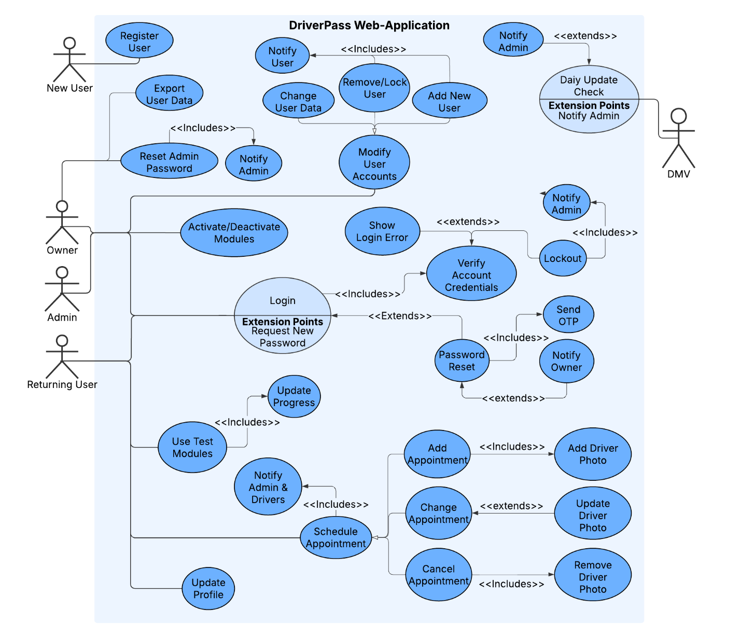

UML Activity Diagrams
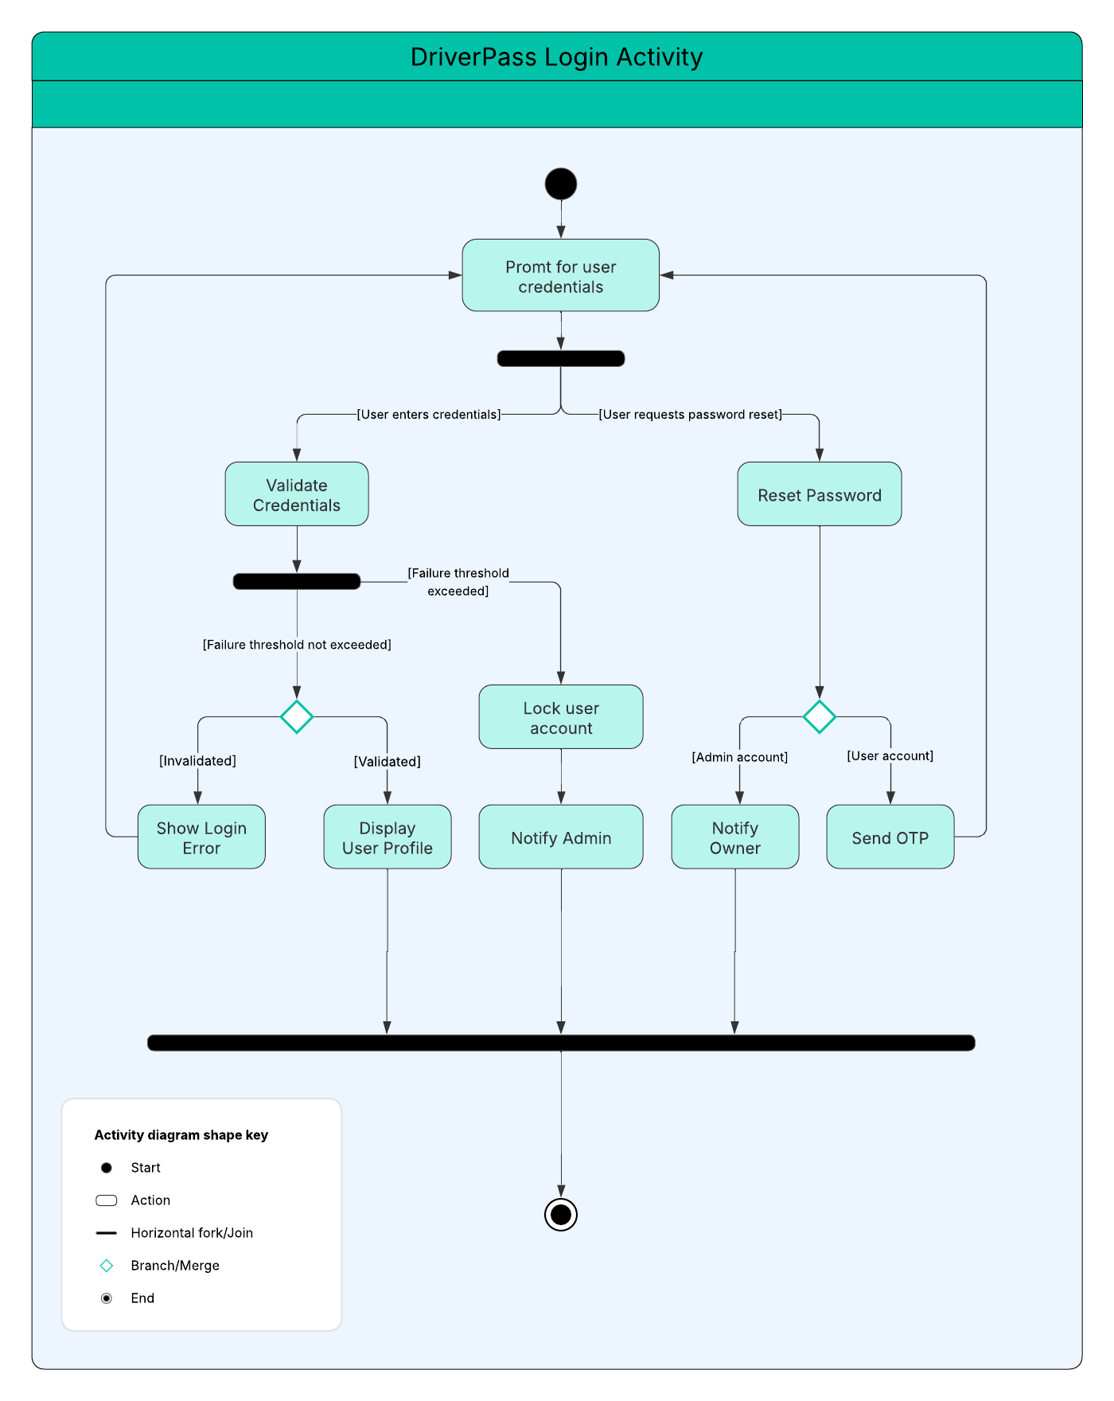

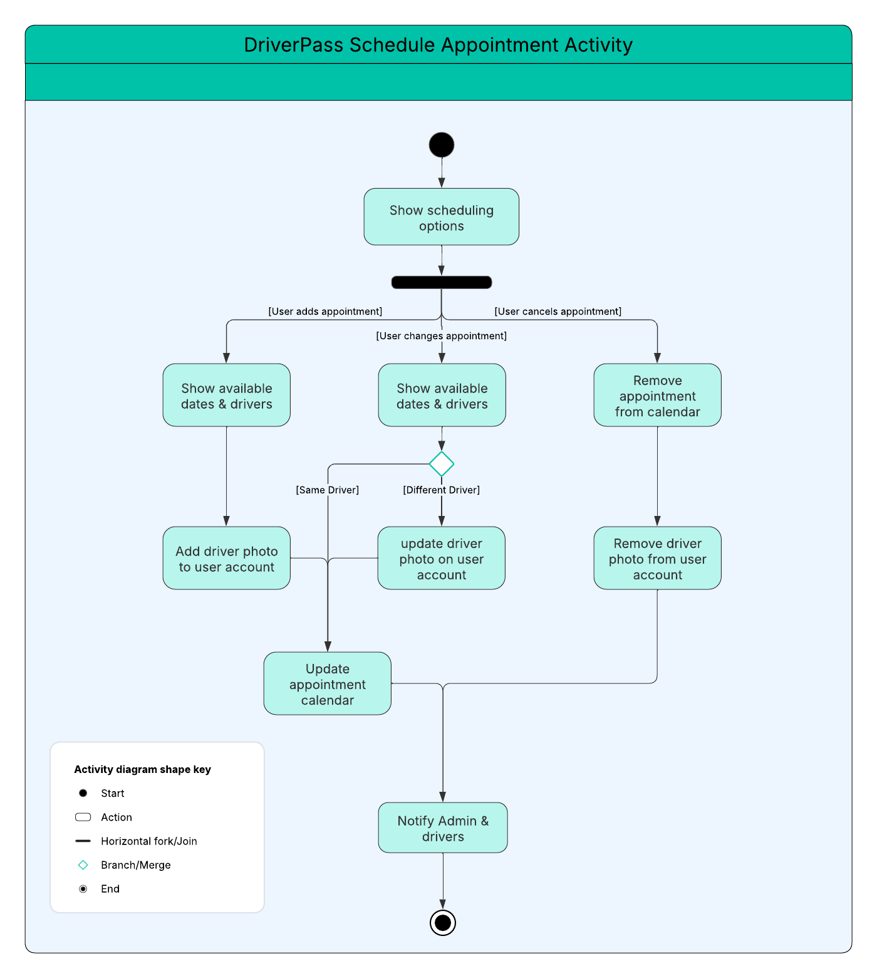

UML Sequence Diagram

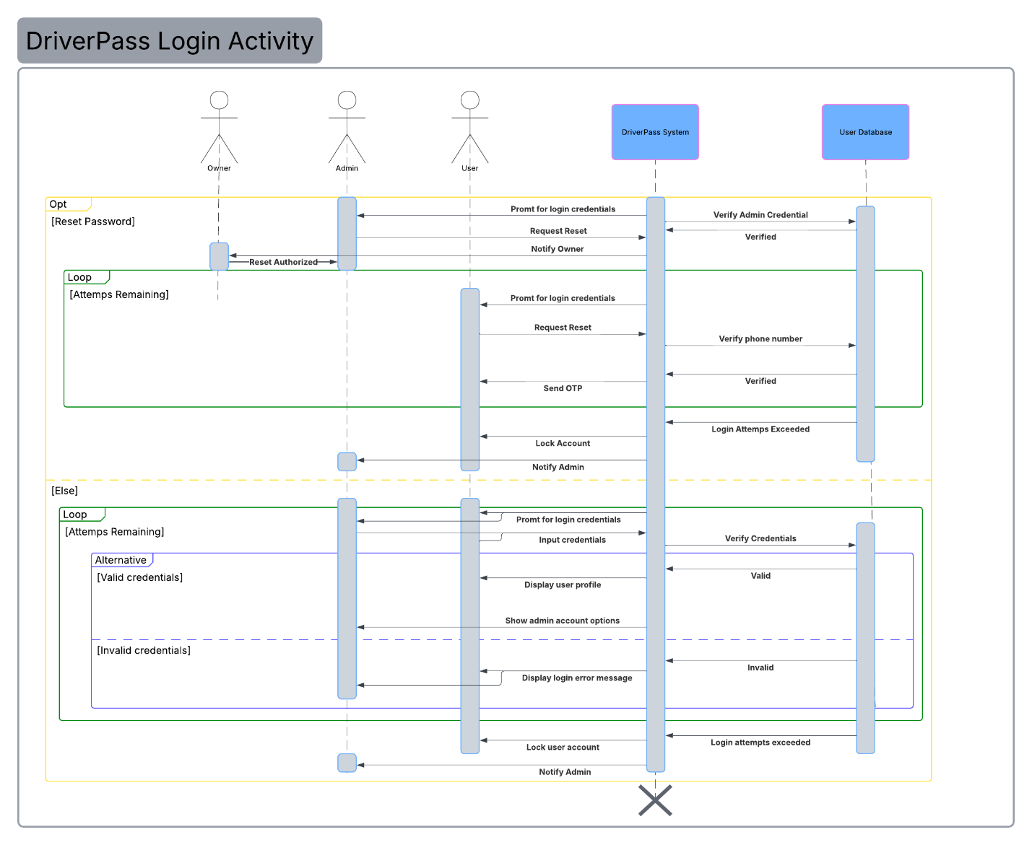

UML Class Diagram
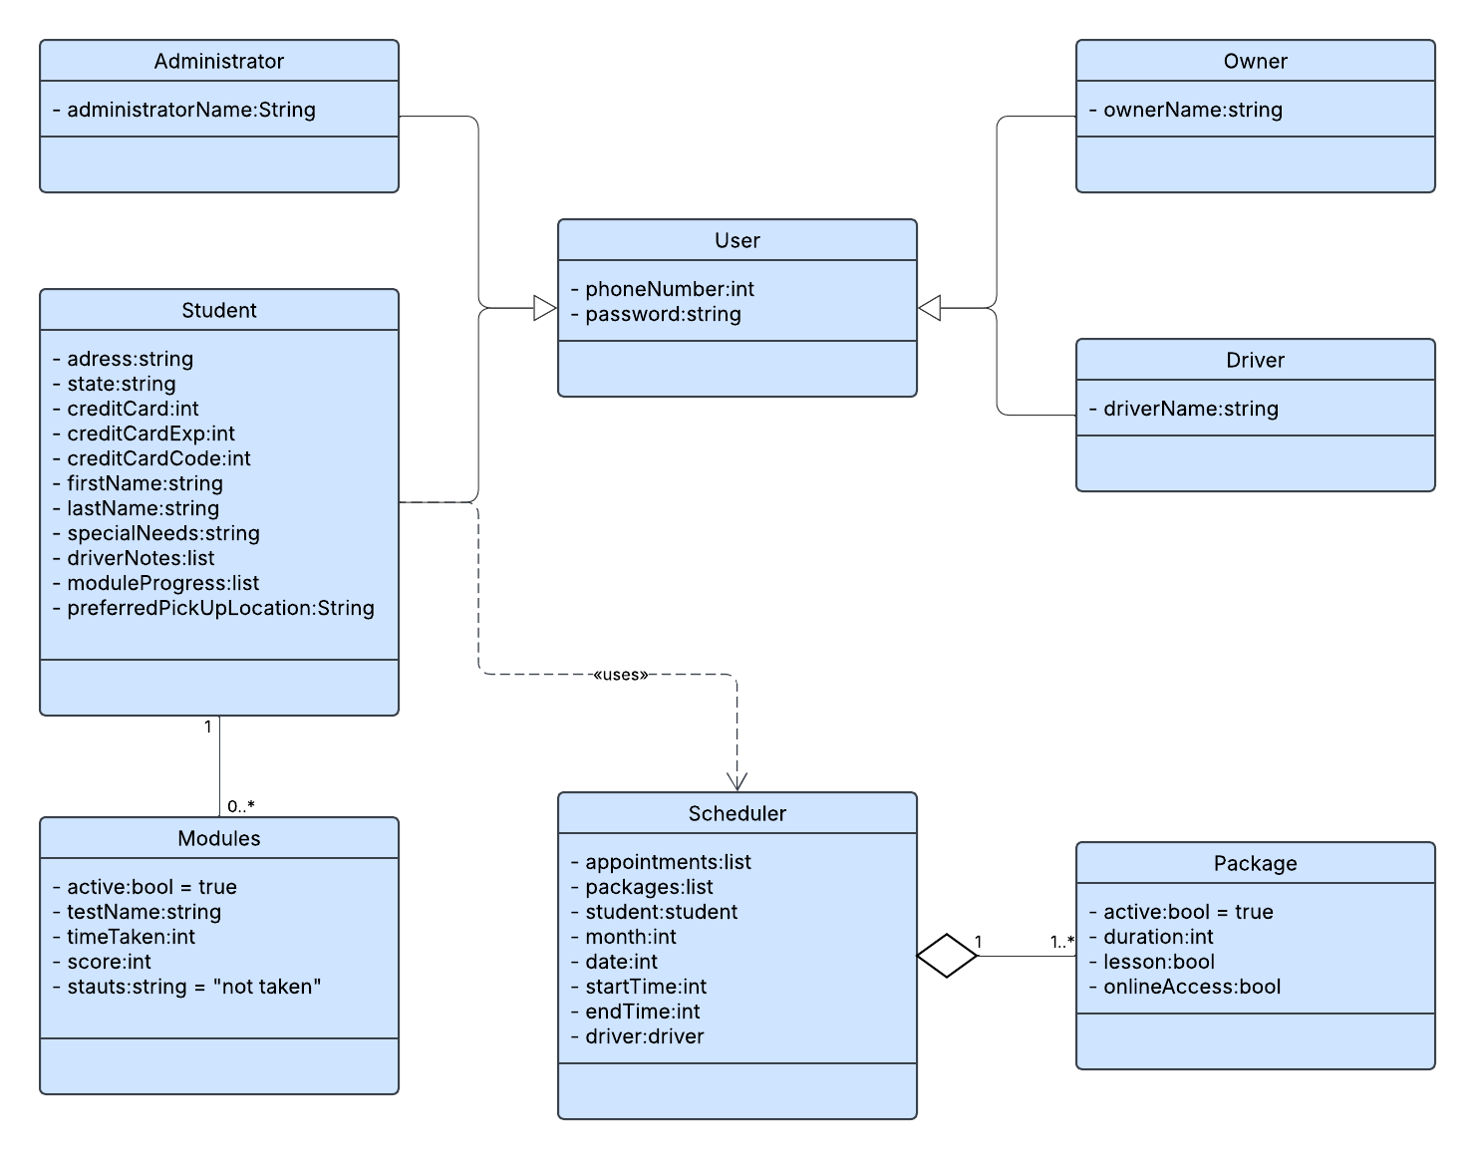

Technical Requirements
- The system will require a cloud service to host the application with web-application server-client support.
- The system requires users to have a reliable internet connection to access the service.
- The system must maintain consistent availability and handle 1000 users without degradation, while ensuring an average page load time below 2 seconds.
- The system shall verify user login, allow automated password resets for users, & prevent brute force attacks by limiting login attempts and locking user accounts.
- The system must comply with encryption standards for user data security.
- The system must work across all major browsers to maximize compatibility and user access.

